**最佳三人組**

R11546014 **劉怡葶, R12522615 王邑安, r12522621李京睿**

1. Background information

Adaptive Cruise Control (ACC) is an advanced system that automatically adjusts a vehicle's speed to maintain a safe following distance from the cars in front. It's also known as Dynamic Cruise Control and relies on onboard sensors like radar, laser, or cameras to brake when it detects the vehicle approaching another one and accelerates when it's safe to do so. ACC is a crucial component of future smart cars, enhancing safety, convenience, and road capacity by ensuring the right distance between vehicles and reducing driver mistakes.

ACC's benefits include:

* Ensuring a safe following distance.
* Minimizing driver errors.
* Improving passenger safety and comfort.
* Boosting road capacity through optimal vehicle spacing.

ACC’s structure:

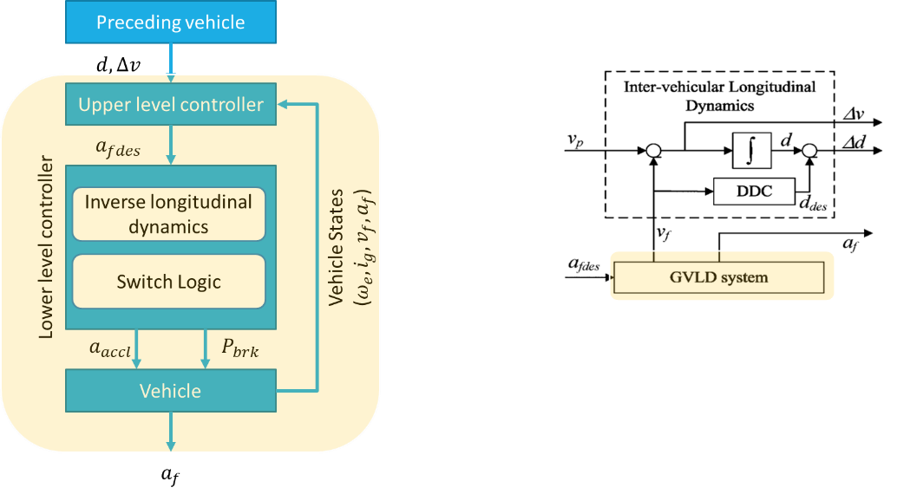

1. Objective function

$$obj:\min_{u\left(k+i | k\right), i=0:P-1}{J\left(u\right)}=\sum_{i=0}^{P-1}{w_{e}e{\left(k+i\right)}^{2}+w_{a}u{\left(k+i\right)}^{2}+w_{v}Δv{\left(k+i \right)}^{2}}$$

$e\left(t\right)=Δx\left(t\right)-\left(r+τ_{hw,d}v_{f}\left(t\right)\right)$: distance error

$Δv\left(t\right)=v_{p}\left(t\right)-v_{f}\left(t\right)$: relative speed

$u\left(t\right)=a_{f}(t)$: acceleration

$w_{e}, w_{a},w_{v}$: weighting factors

1. Design variables/parameters

Variables:

* $e\left(t\right)$: distance error 🡪 A significant absolute distance inaccuracy could violate the space policy. This variable is included to lessen the distance error and prevent violating the space policy.
* $u(a_{f})$: the acceleration of the following(host) car 🡪 We should penalize the use of excessive acceleration while considering riding comfort.
* $Δv\left(t\right)$: relative speed 🡪 If the absolute or relative speed is high, it could violate space regulations and potentially lead to major collisions. This variable is provided to aid in lowering relative speed in order to prevent these scenarios from occurring.

Parameters:

* TTC(time to collision): The time before a collision happens between involved vehicles/objects/subjects if their speeds would not change and taking into account their paths.
* $d_{safe}$: The safe distance to prevent collision.($d_{safe}=r+τ_{hw,d}v_{f}\left(t\right)$)
* $r$: Minimum safe distance
* $e_{min}, e_{max}$: Minimum and maximum distance error
* $Δv_{min}, Δv_{max}$: Minimum and maximum relative speed
* $u_{min}, u_{max}$: Minimum and maximum acceleration
* $w_{e}, w_{a},w_{v}$: Weighting factors
* $P ∙T_{s}$: Predictive horizon($P$:the length of predictive horizon, $T_{s}$: sampling time)

1. Constraints

* Give constraints to distance to preceding car

$$Δx\left(k+i+1 | k\right)+\left(TTC+τ_{h}\right)Δv\left(k+i+1 | k\right)≥r+τ_{hw,d}\left(k+i+1 | k\right), i=0:P-1$$

1. Design boundaries

* Boundary of distance to preceding car:
$$Δx≥0$$

* Boundary of car speed:
$$0≤v_{f}, v_{p}≤150 kph$$

* Boundary of acceleration($m/s^{2}$):
$$u_{min}=-1.5≤u\left(k+i | k\right)≤u_{max}=0.6 , i=0:P-1$$

* Boundary of distance error($m$):
$$e_{min}=-5≤Δx\left(k+i+1 | k\right)≤e_{max}=6,i=0:P-1$$

* Boundary of relative velocity($m/s$):

$$Δv_{min}=-1≤Δv\left(k+i+1 | k\right)≤Δv_{max}=0.9,i=0:P-1$$

1. Assumption

* Not consider wind drag influence
* High radar accuracy
* No calculation delay
* No implementation delay

1. Terminology

* $τ_{hw,d}$: time headway is defined as the distance headway divided by the own vehicle's speed.
* $Δx$: distance to preceding car
* $v_{p}$: the velocity of the preceding car
* $v_{f}$: the velocity of the following(host) car